Eureka:

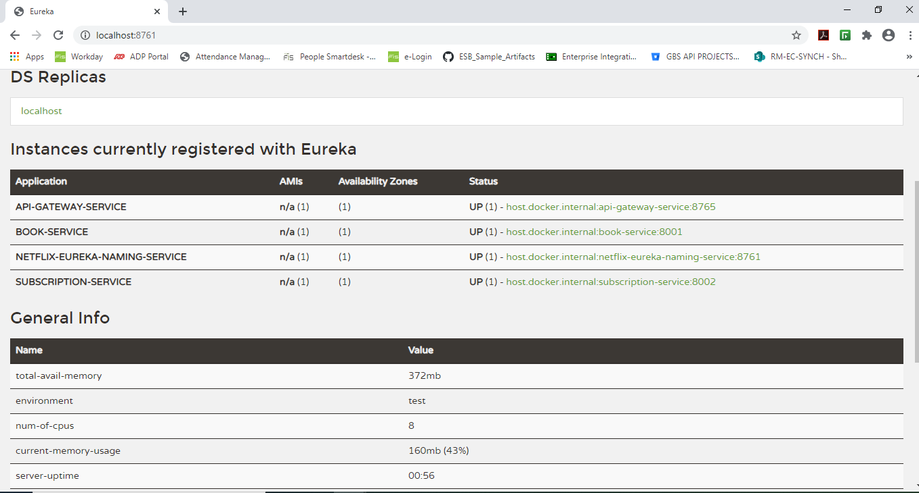

GET <http://localhost:8001/books>

[

    {

        "id": 1,

        "bookId": "B1212",

        "name": "History of Amazon Valley",

        "author": "Ross Suarez",

        "avaliableCopies": 2,

        "totalCopies": 2

    },

    {

        "id": 2,

        "bookId": "B4232",

        "name": "Language Fundamentals",

        "author": "H S Parkmay",

        "avaliableCopies": 5,

        "totalCopies": 5

    },

    {

        "id": 3,

        "bookId": "B4552",

        "name": "Head First Java 1.8",

        "author": "OReilly",

        "avaliableCopies": 10,

        "totalCopies": 10

    }

]

GET <http://localhost:8001/books/B1212>

{

    "id": 1,

    "bookId": "B1212",

    "name": "History of Amazon Valley",

    "author": "Ross Suarez",

    "avaliableCopies": 2,

    "totalCopies": 2

}

GET <http://localhost:8002/subscriptions>

[

    {

        "id": 1,

        "subscriberName": "John",

        "dateSubscribed": "12-JUN-2020",

        "dateReturned": null,

        "bookId": "B1212"

    }

]

POST <http://localhost:8002/subscription>

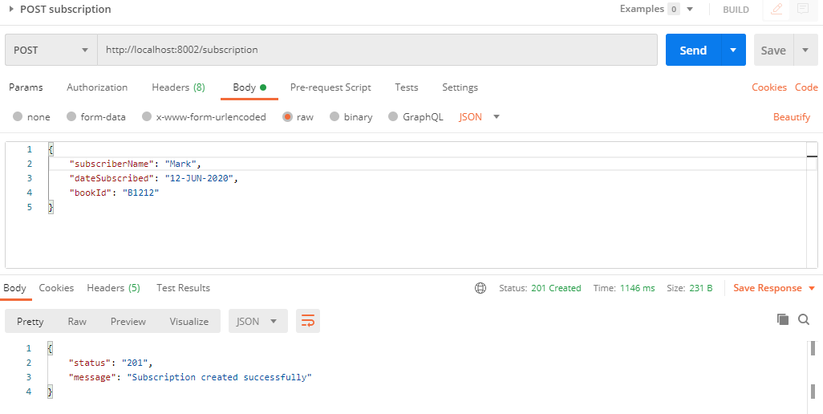

GET <http://localhost:8002/subscriptions> - After POST subscription

[

    {

        "id": 1,

        "subscriberName": "John",

        "dateSubscribed": "12-JUN-2020",

        "dateReturned": null,

        "bookId": "B1212"

    },

    {

        "id": 2,

        "subscriberName": "Mark",

        "dateSubscribed": "12-JUN-2020",

        "dateReturned": null,

        "bookId": "B1212"

    }

]

GET <http://localhost:8001/books/B1212> - After POST subscription

{

    "id": 1,

    "bookId": "B1212",

    "name": "History of Amazon Valley",

    "author": "Ross Suarez",

    "avaliableCopies": 1,

    "totalCopies": 2

}

POST <http://localhost:8002/subscription>

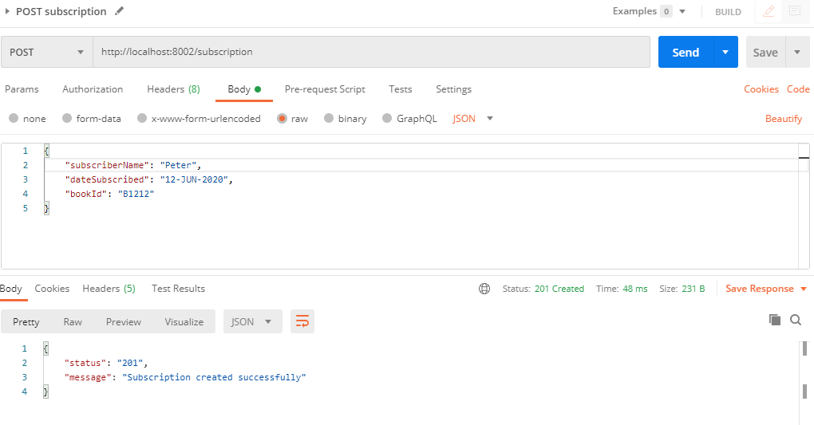

GET <http://localhost:8002/subscriptions> - After POST subscription

[

    {

        "id": 1,

        "subscriberName": "John",

        "dateSubscribed": "12-JUN-2020",

        "dateReturned": null,

        "bookId": "B1212"

    },

    {

        "id": 2,

        "subscriberName": "Mark",

        "dateSubscribed": "12-JUN-2020",

        "dateReturned": null,

        "bookId": "B1212"

    },

    {

        "id": 3,

        "subscriberName": "Peter",

        "dateSubscribed": "12-JUN-2020",

        "dateReturned": null,

        "bookId": "B1212"

    }

]

GET <http://localhost:8001/books/B1212> - After POST subscription

{

    "id": 1,

    "bookId": "B1212",

    "name": "History of Amazon Valley",

    "author": "Ross Suarez",

    "avaliableCopies": 0,

    "totalCopies": 2

}

POST <http://localhost:8002/subscription> - No available copies returns 422

